# Intro to JavaScript Week 5 Coding Assignment

**Points possible:** 75  
  
**URL to Your GitHub Repository:**

**Instructions:** In VS Code, or an IDE of your choice, write the code that accomplishes the objectives listed below. Ensure that the code compiles and runs as directed. Take screenshots of the code and of the running program (make sure to get screenshots of all required functionality) and paste them in this document where instructed below. Create a new repository on GitHub for this week’s assignments and push this document, with your JavaScript project code, to the repository. Add the URL for this week’s repository to this document where instructed and submit this document to your instructor when complete.

**URL of GitHub:** [**https://github.com/RobinStraka/week5Assignment.git**](https://github.com/RobinStraka/week5Assignment.git)

**Coding Steps:**

1. Create a menu app as seen in this week’s video. What you create is up to you as long as it meets the following requirements.
   1. Use at least one array.
   2. Use at least two classes.
   3. Your menu should have the options to create, view, and delete elements.

**Screenshots of Code:**

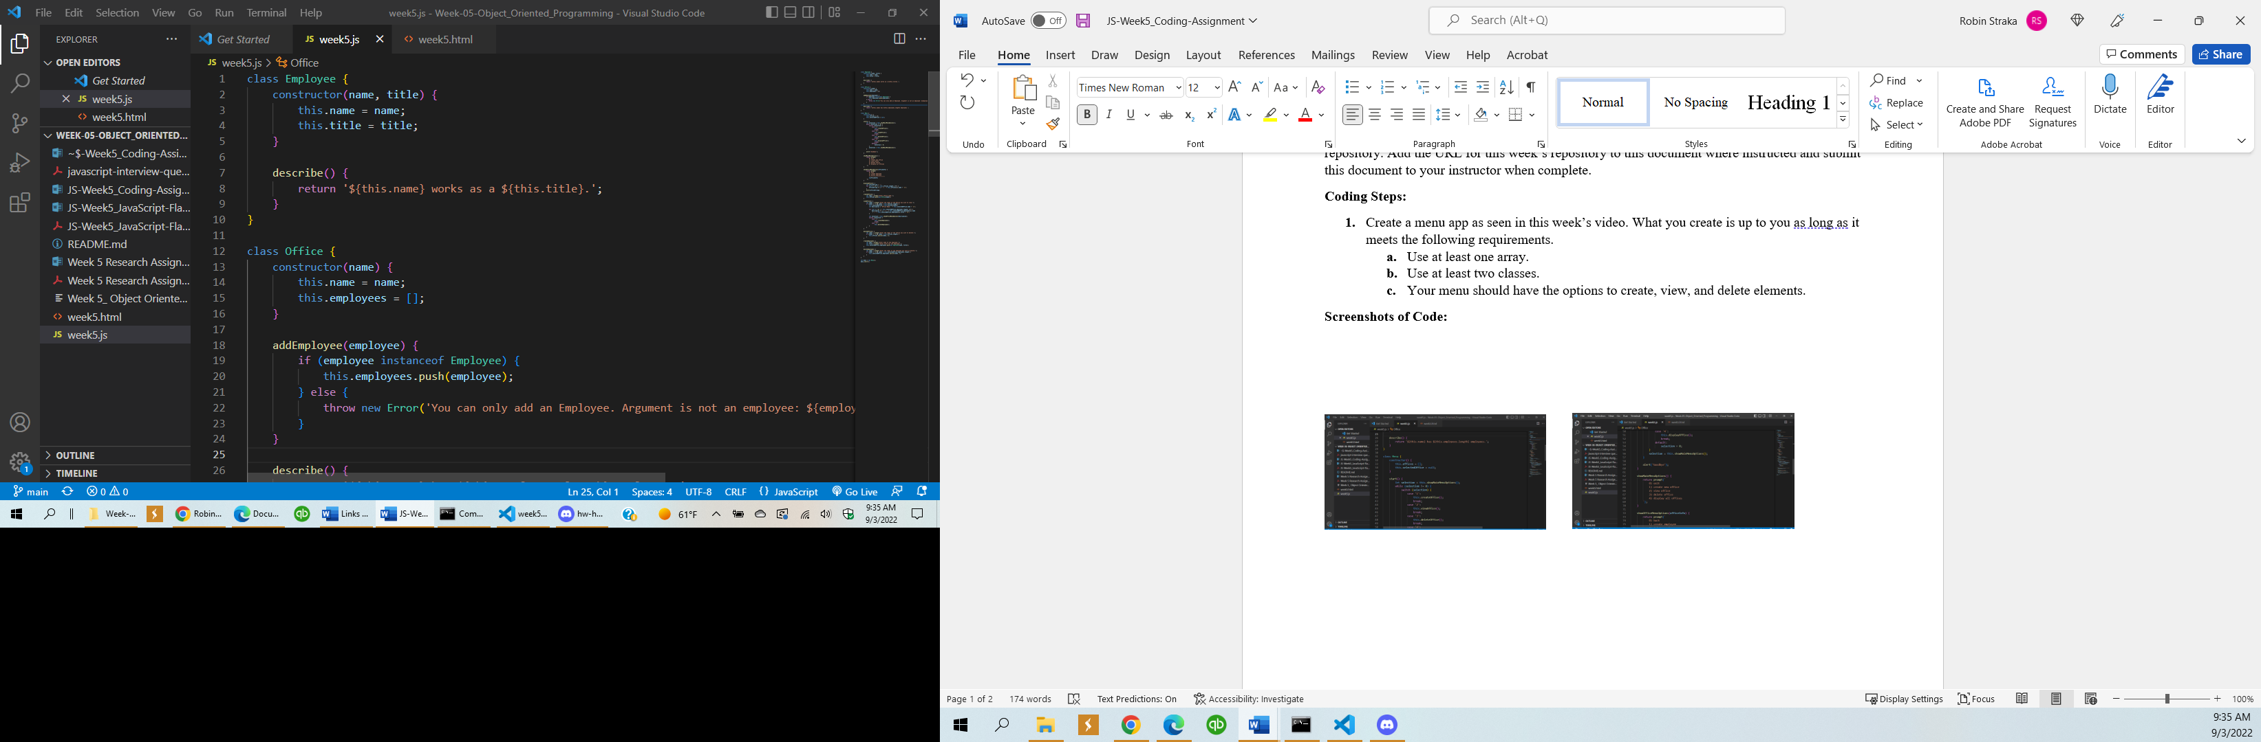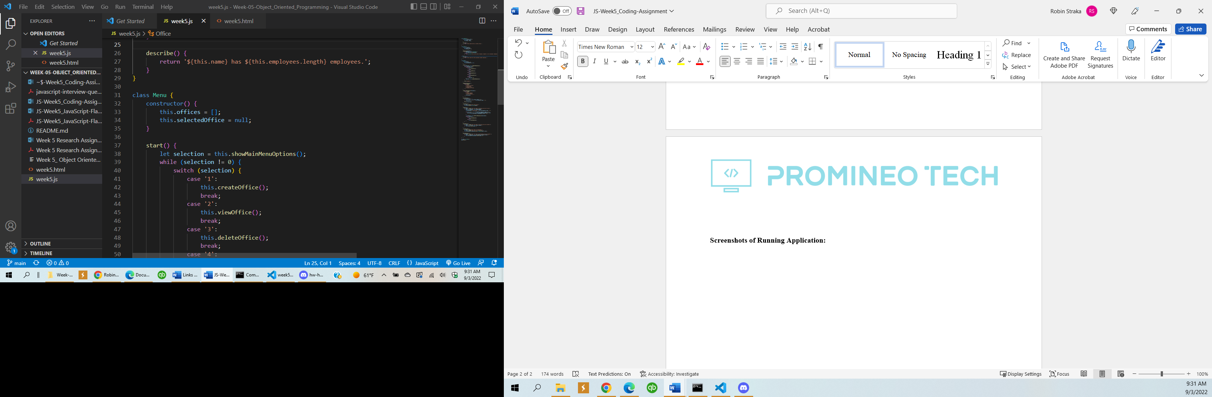

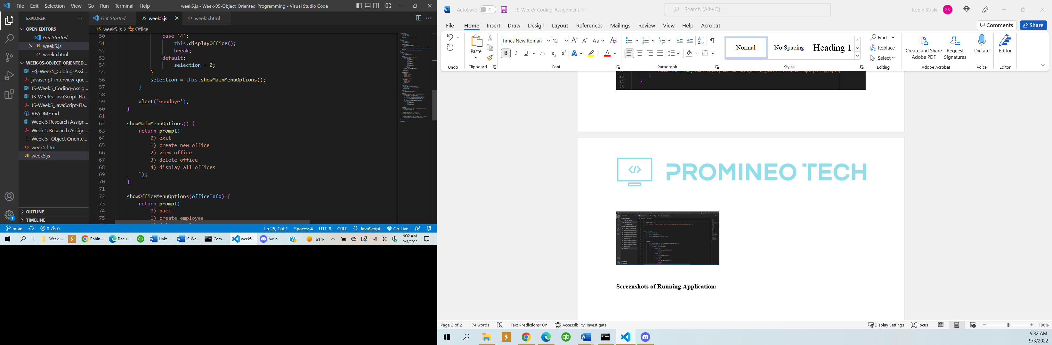 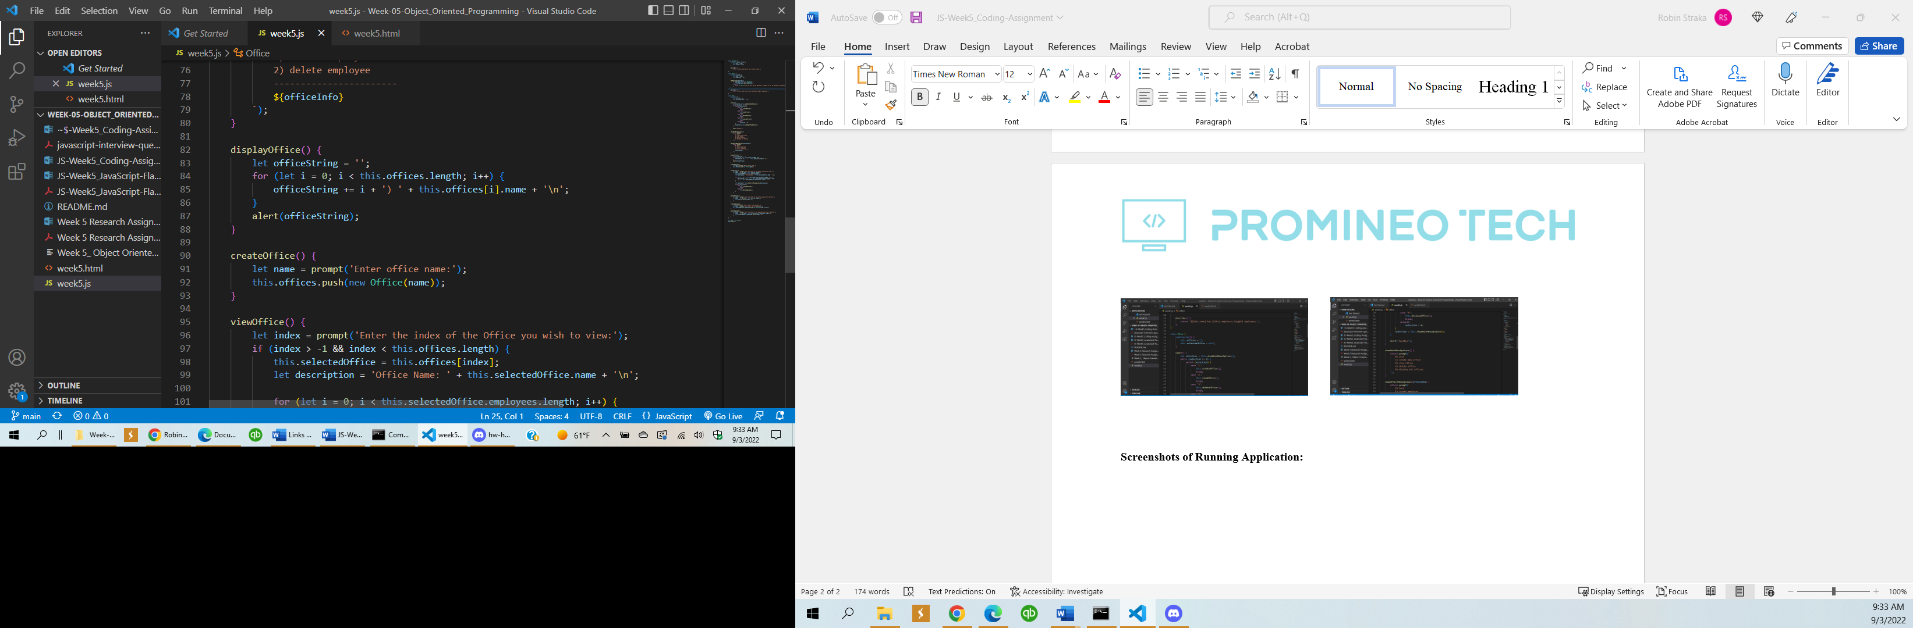

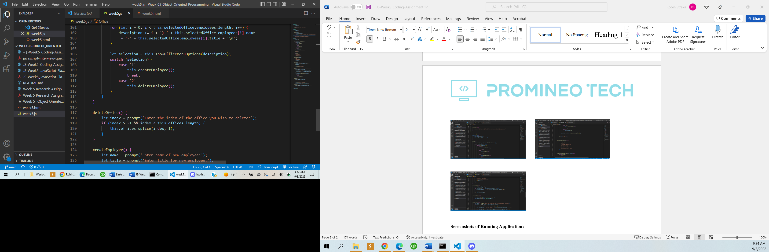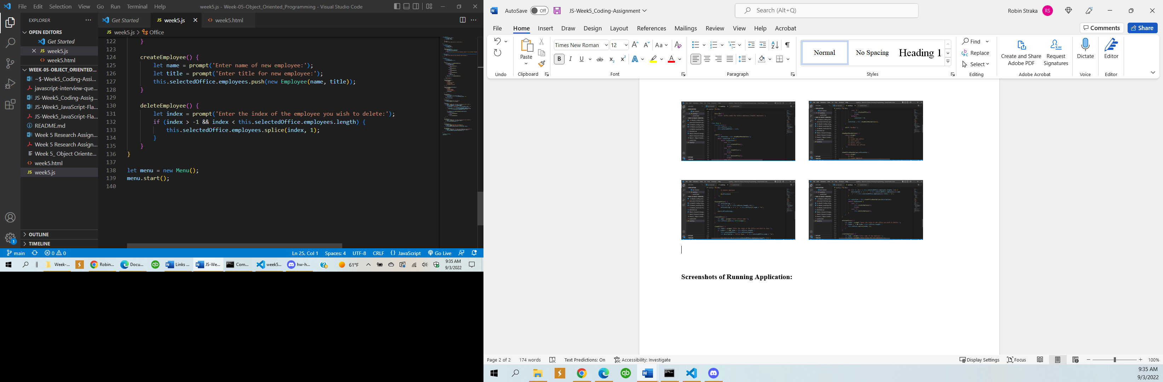

**Screenshots of Running Application:**

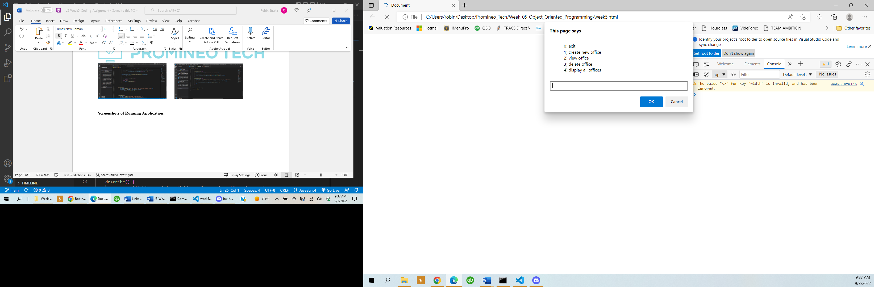 **Entered 1**

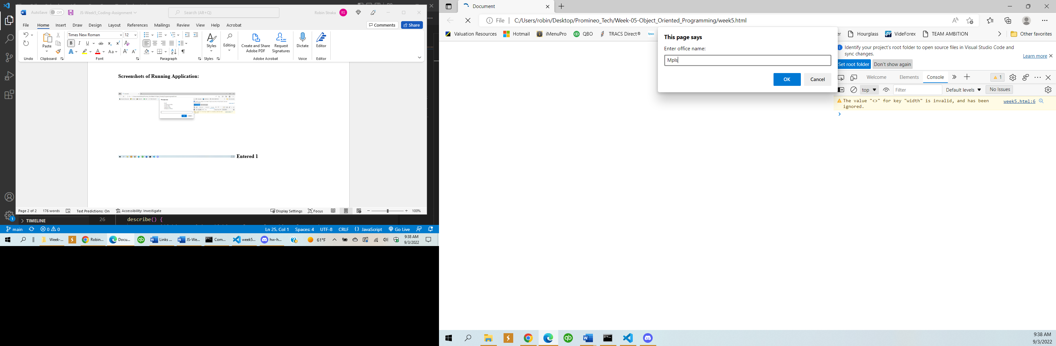**Entered name and ok**

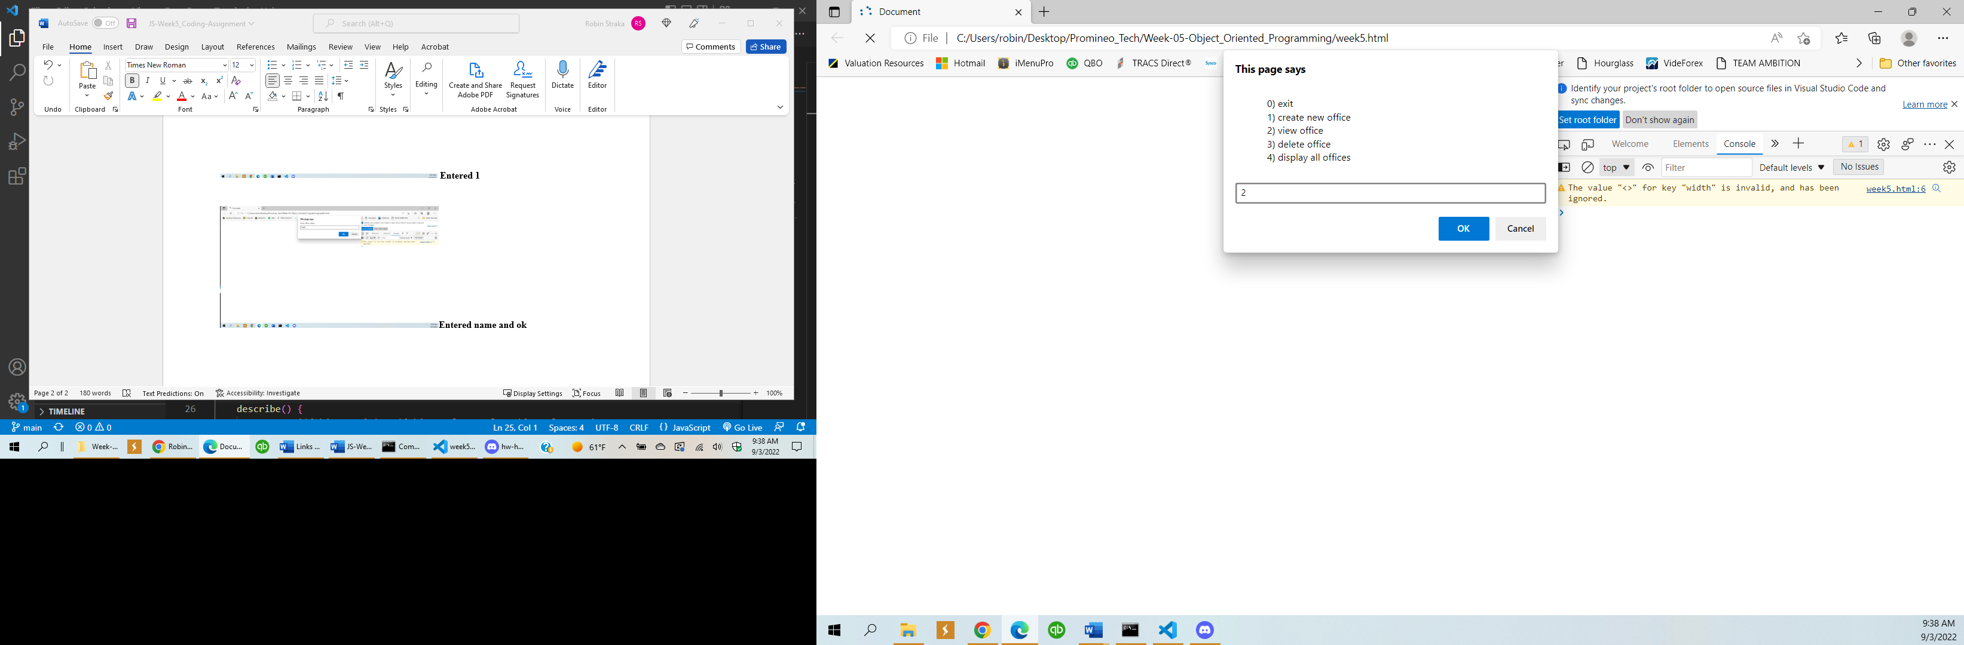

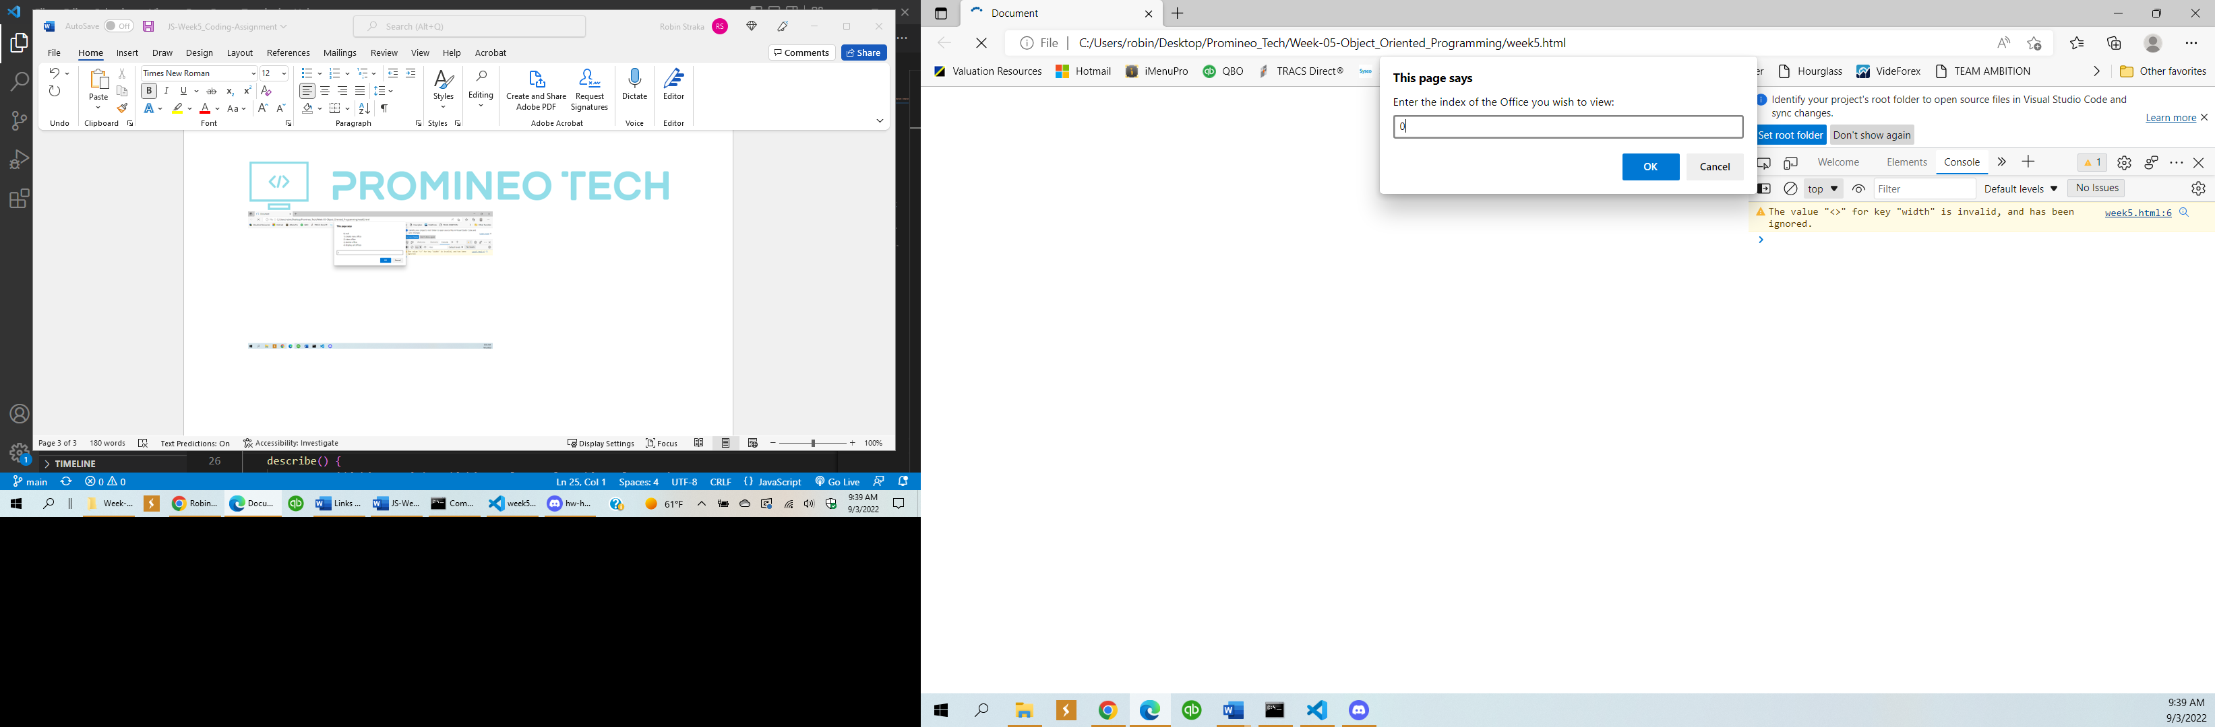

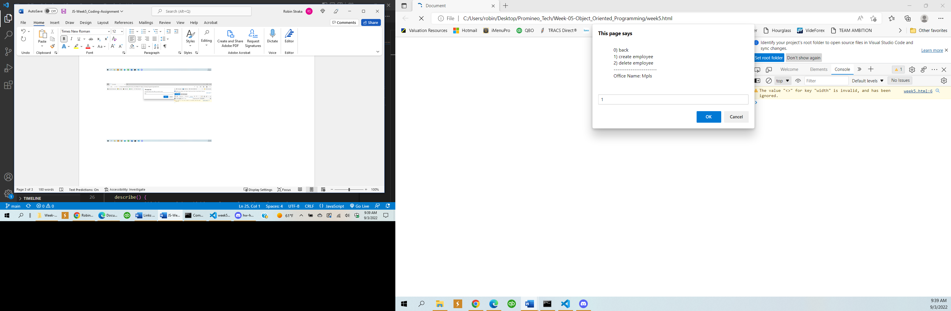

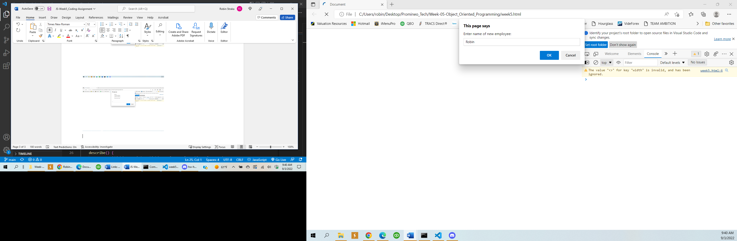

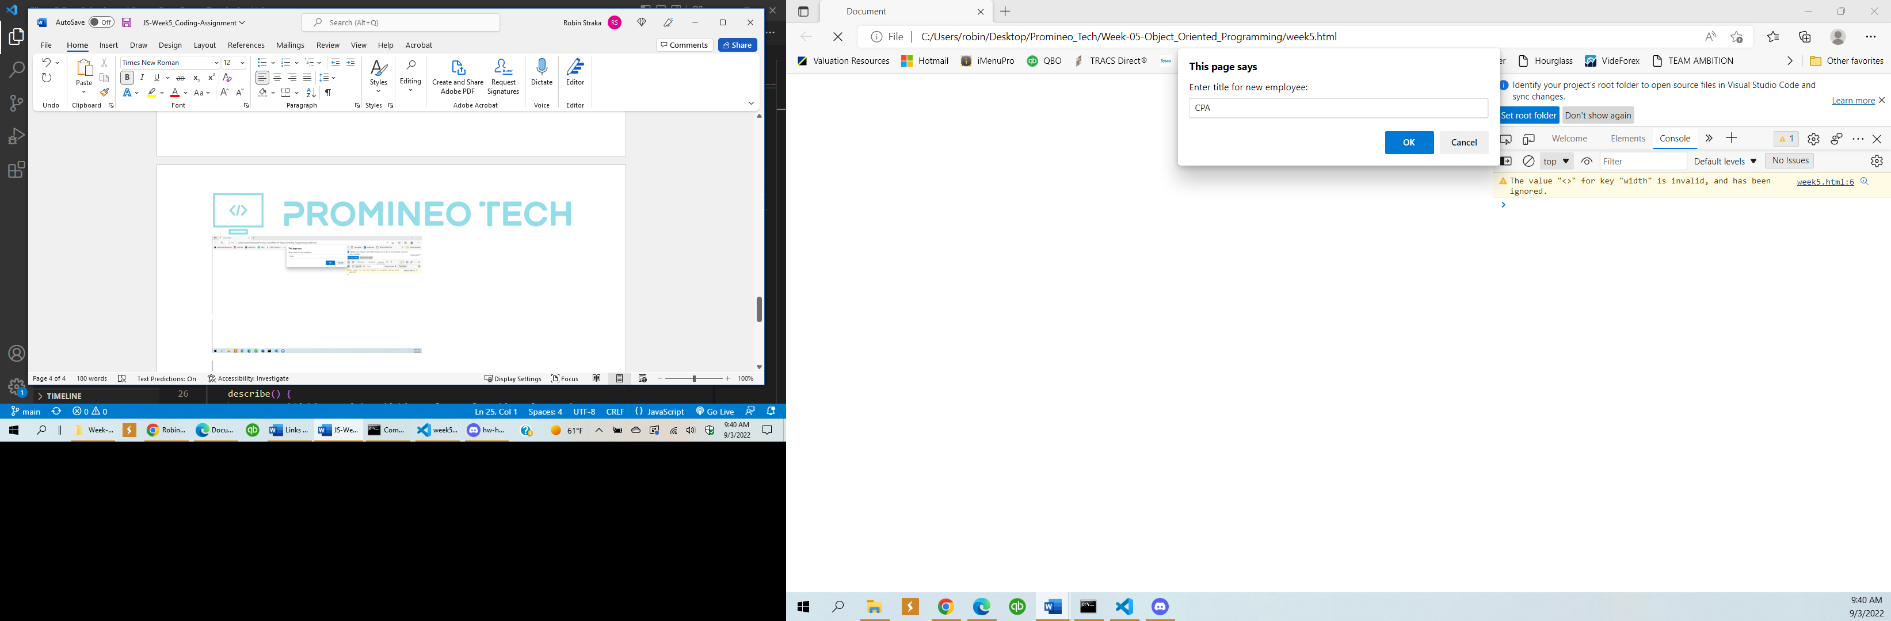

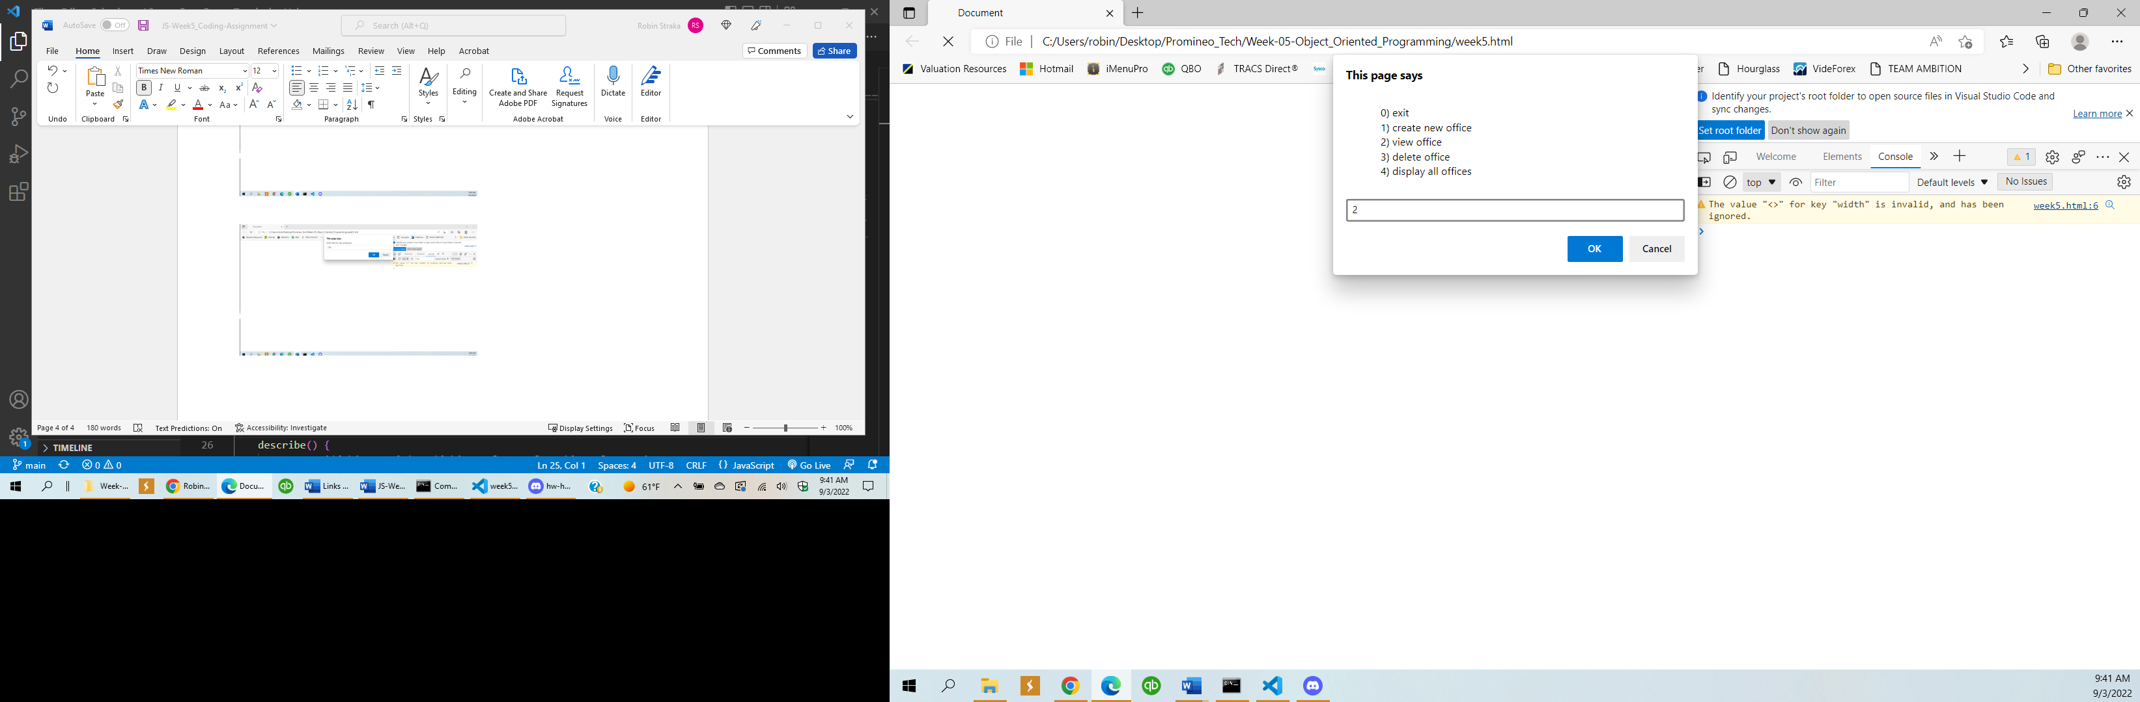**Entered index of 0**

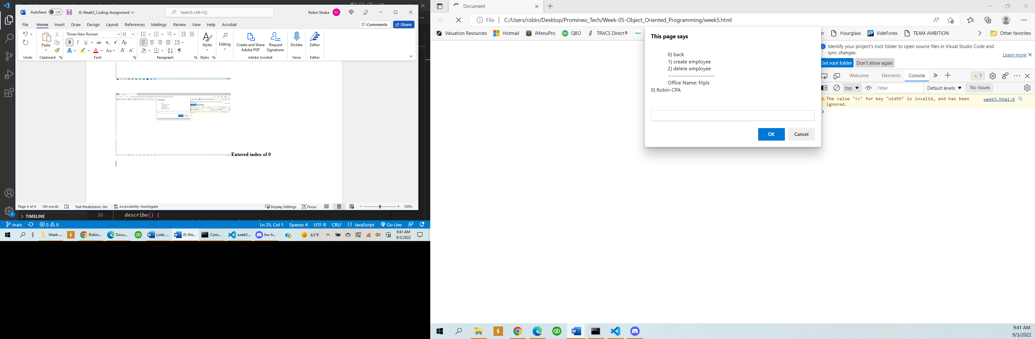

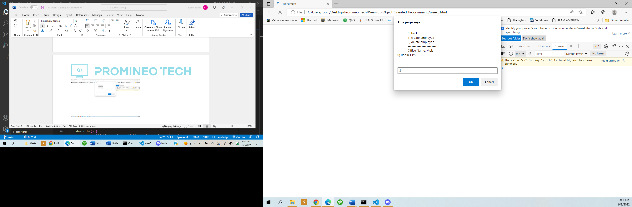

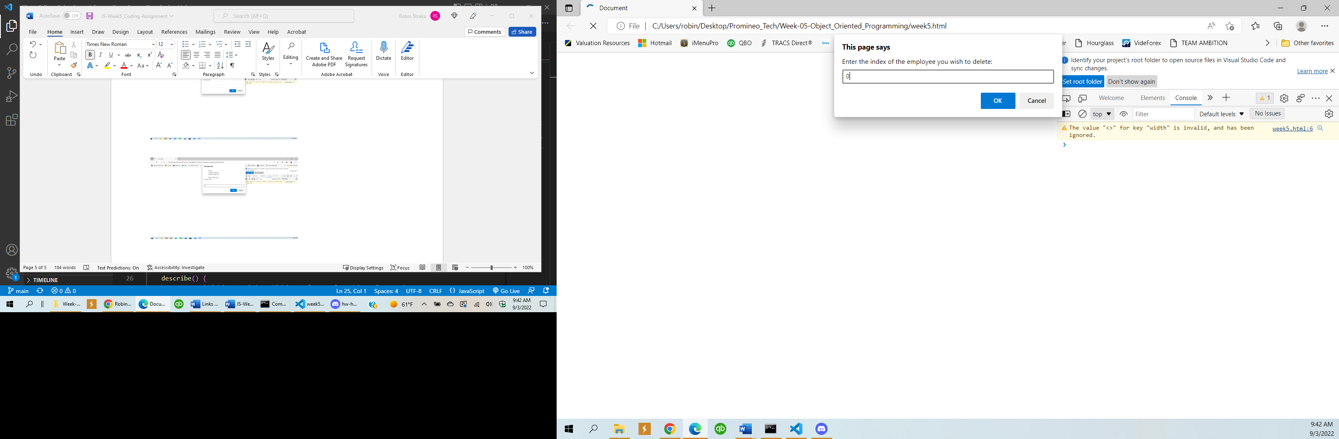

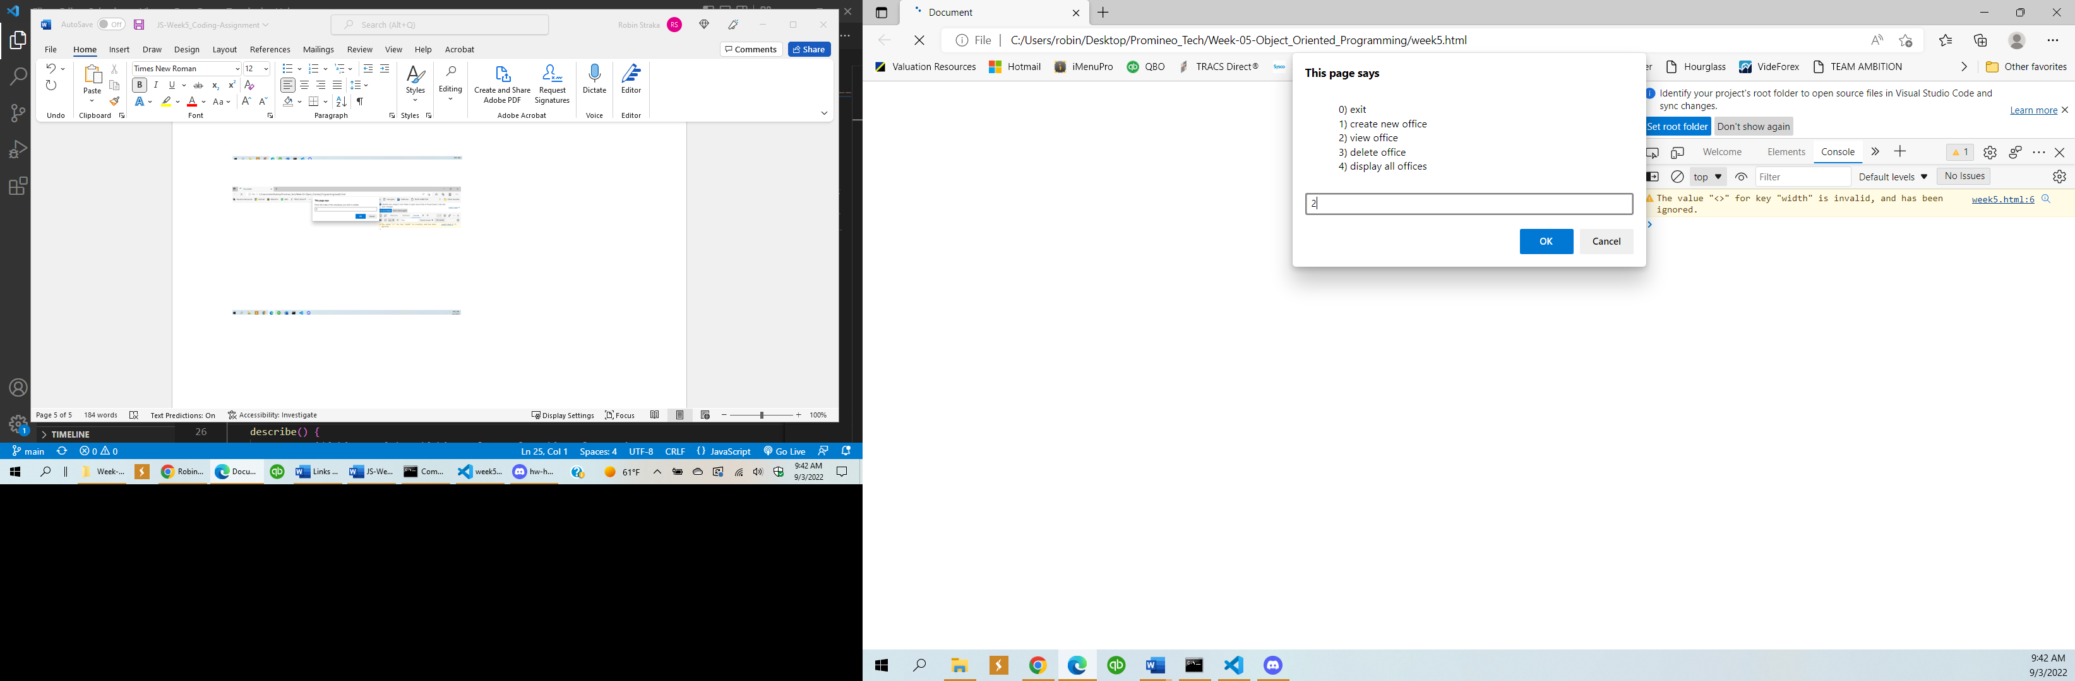**Entered index of 0**

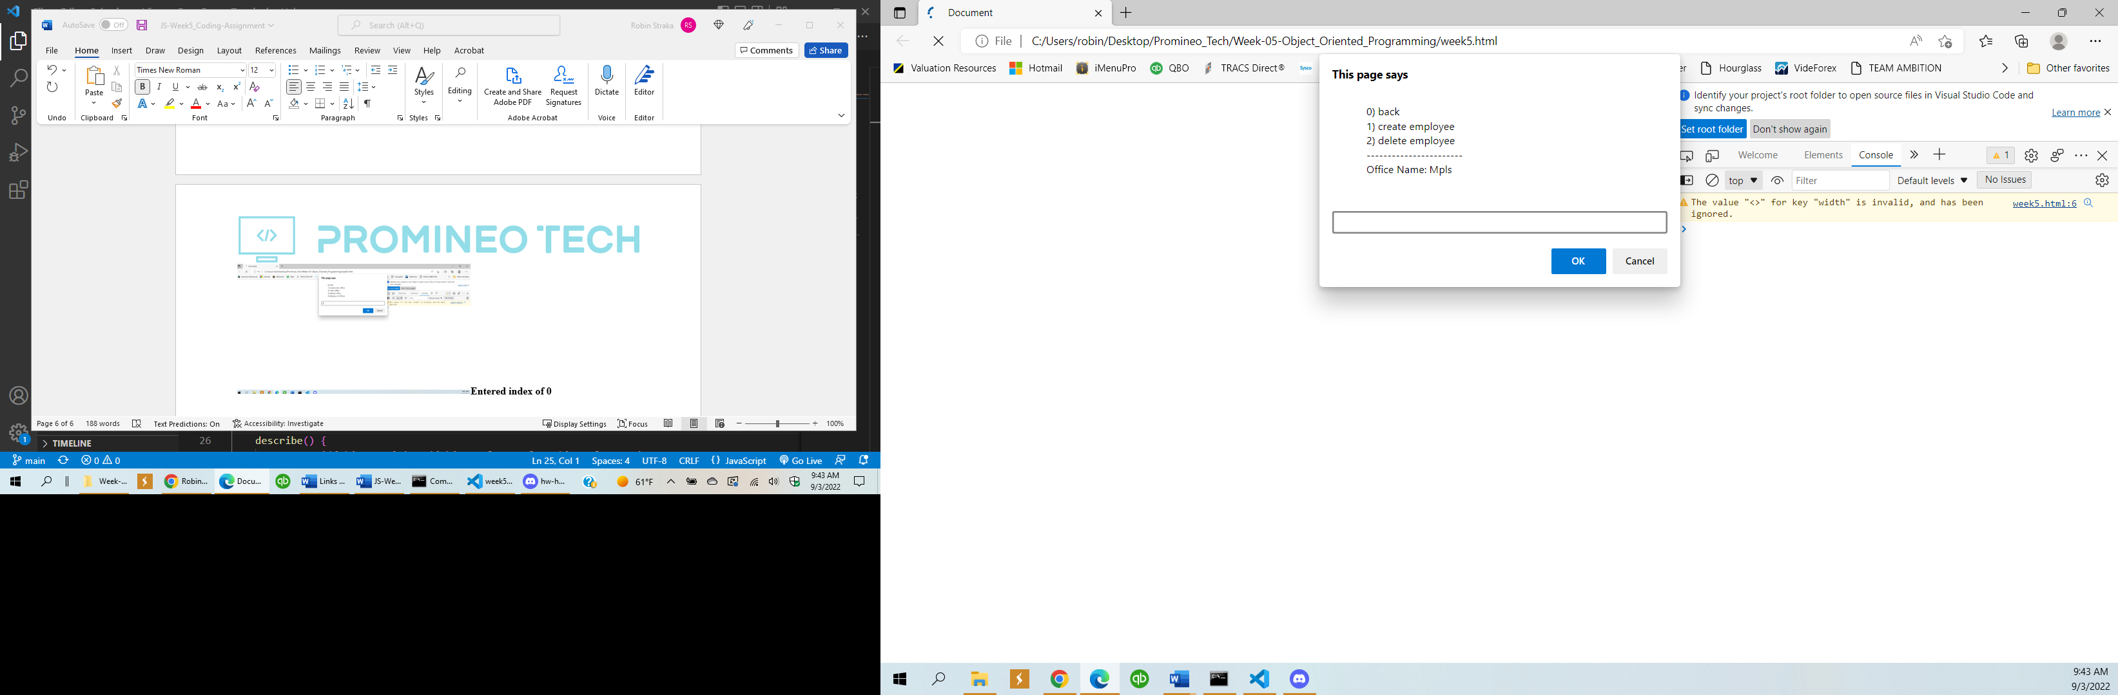 **Confirm employee deleted**

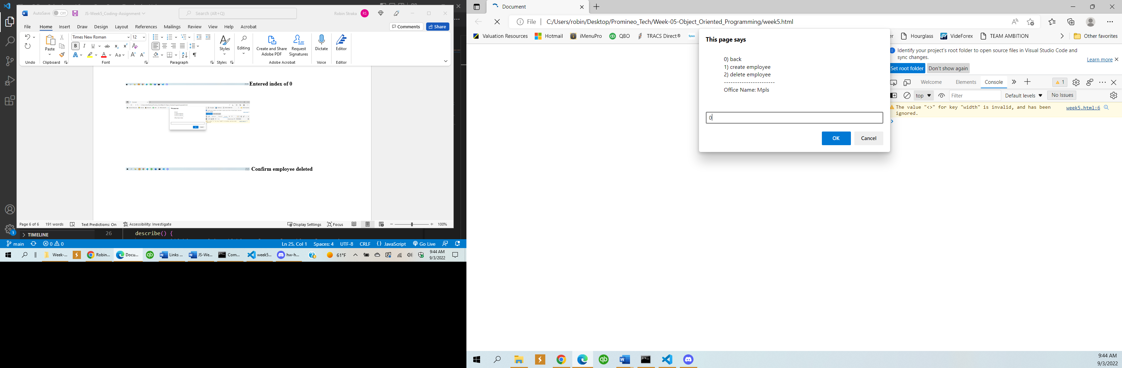

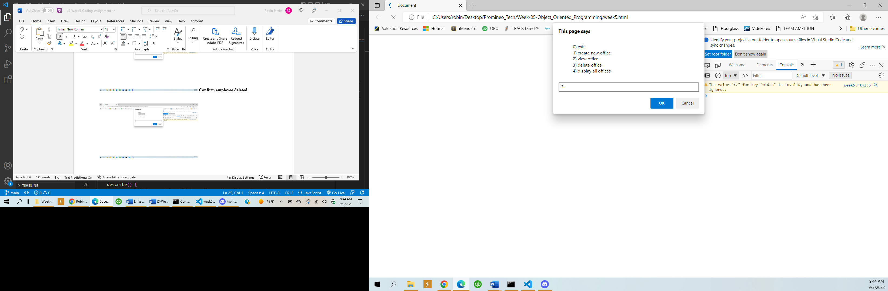**Entered index of 0**

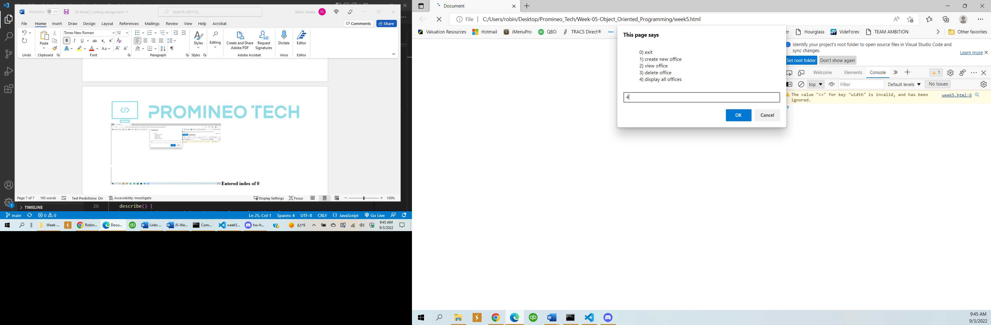

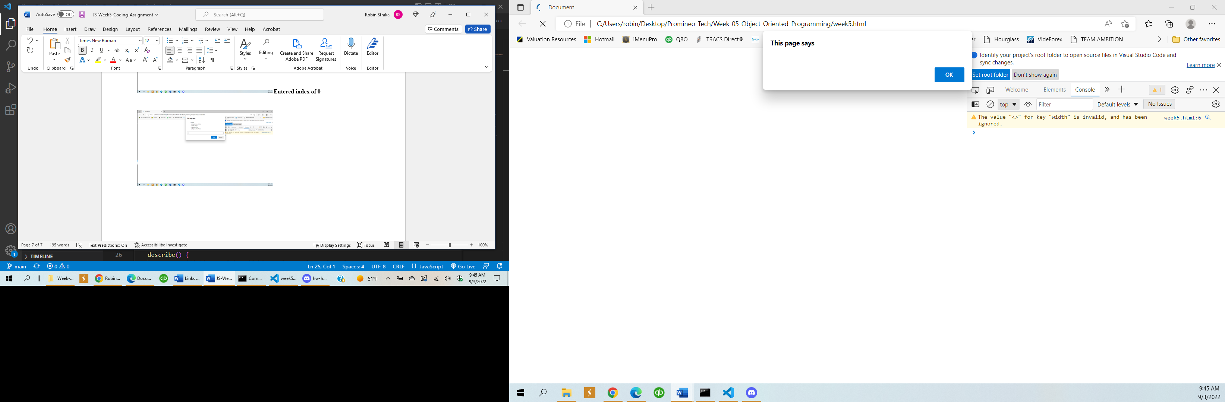**Confirms Office deleted**

